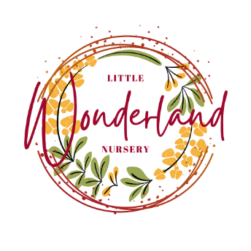
Allergies and Allergic Reactions Policy

HSCS: 1.13, 1.14, 1.15, 1.19, 1.24, 1.28, 1.37, 2.23, 3.4, 3.14, 3.17, 3.18, 3.20, 3.21, 3.25, 4.2, 4.11, 4.14, 4.27, 5.17,
*Delete as appropriate

At Little Wonderland Nursery Ltd we are aware that children may have or develop an allergy resulting in an allergic reaction.

We aim to ensure allergic reactions are minimised or, where possible, prevented and that staff are fully aware of how to support a child who may be having an allergic reaction.

Our procedures
- All staff are made aware of the signs and symptoms of a possible allergic reaction in case of an unknown or first reaction in a child. These may include a rash or hives, nausea, stomach pain, diarrhoea, itchy skin, runny eyes, shortness of breath, chest pain, swelling of the mouth and/or tongue, swelling of the airways to the lungs, wheezing and anaphylaxis
- We ask parents to share all information about allergic reactions and allergies on their child’s registration form and to inform staff of any allergies discovered after registration
- We share all information with all staff, volunteers and students to ensure children are kept safe from harm.
- Where a child has a known allergy, the nursery manager will carry out a full allergy risk assessment procedure with the parent prior to the child starting the nursery and/or following notification of a known allergy. This assessment is shared with all staff and may involve displaying photos of the children along with their known allergies in the kitchen or nursery rooms, where applicable
- All food prepared for a child with a specific allergy is prepared in an area where there is no chance of contamination and served on equipment that has not been in contact with this specific food type, e.g. nuts, gluten
- The manager, staff and parents will work together to ensure a child with specific food allergies receives no food at nursery that may harm them. This may include designing an appropriate menu or substituting specific meals on the current nursery menu
- Seating is monitored for children with allergies. Where deemed appropriate staff will sit with children who have allergies and where age/stage appropriate staff will discuss food allergies with the children and the potential risks
- If a child has an allergic reaction to food, a bee or wasp sting, plant etc. a paediatric first aid trained member of staff will act quickly and administer the appropriate treatment, if necessary. We will inform parents and record the information in the incident book and on the allergy register
- If an allergic reaction requires specialist treatment, e.g. an EpiPen, then at least two members of staff working directly with the child and the manager will receive specific medical training to be able to administer the treatment to each individual child.

Food information (Scotland) regulations 2014
We incorporate additional procedures in line with the Food information regulations 2014 (FIR) including displaying our weekly menus on our online system – Eylog, identifying any of the 14 allergens that are used as ingredients in any of our dishes.

In the event of a serious allergic reaction and a child needing transporting to hospital, the nursery manager or staff member will:
- Call for an ambulance immediately if the allergic reaction is severe. Staff will not attempt to transport the sick child in their own vehicle
- Ensure someone contacts the parent(s) whilst waiting for the ambulance, and arrange to meet them at the hospital
- Arrange for the most appropriate member of staff to accompany the child, taking with them any relevant information such as registration forms, relevant medication sheets, medication and the child’s comforter
- Redeploy staff if necessary to ensure there is adequate staff deployment to care for the remaining children. This may mean temporarily grouping the children together
- Inform a member of the management team immediately
- Remain calm at all times and continue to comfort and reassure the child experiencing an allergic reaction. Children who witness the incident may also be affected by it and may need lots of cuddles and reassurance. Staff may also require additional support following the incident
- Where a serious incident occurs and a child requires hospital treatment, the Care Inspectorate will be informed.

This policy is updated at least annually in consultation with staff and parents and/or after a serious incident.

This policy was created on: | Signed on behalf of the nursery | Date for review
20/08/2024 | S.Sneddon | 20/08/2025

Links to UNCRC Articles: 1, 2, 3, 5, 16, 23, 24

